THE BEST A NETWORK CAN GET: Human networking and the worldwide’s greatest innovation - BRAC - began when a million people died all around Fazle Abed during a cyclone - he had just been promoted as the oil company Shell's CEO in Bangladesh. He decided marketing oil was relatively meaningless, went back to London to resign and sell his house, and by 1972 went to live in the cyclone zone - 50 square miles of rural Bangladesh (ie no electricity, no phones, next to no roads) -to see how he could help the villagers
Thus the world's first bottom-up disaster relief network was born as was the largest peer to peer community training network. Today NPR estimates that BRAC’s livelihood education has reached 150 million people, and their race to end poverty. All this began when Fazle started by organising those who had a relief skill to train others and making sure global relief organisations trusted BRAC Muslim villagers to empower their own resiliency and development networks.
While BRAC’s grassroots network was forming, a million person famine hit the whole of Bangladesh -particularly mothers and children - so BRAC and China started improving rice crop science so that women villagers would in future have food security- agricultural markets designed by and for the poorest became BRAC's second great how to. 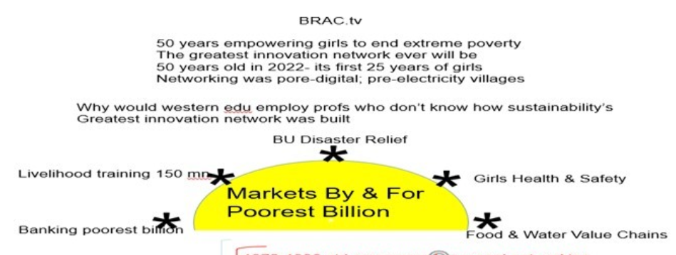
BRAC increasingly focused on women and girls networking because in Bangladesh the healthiest men are often sent abroad to earn remittances and, truth to tell, historic village cultures had never valued women’s lives as much as men. China was going through a parallel cultural revolution of Women Hold up Half the Sky.
1978 saw the world celebrating the year of the child- since a quarter of all infants were dying in Bangladesh villages due to extreme diarrhea, Fazle determined that BRAC needed to test how to train village mothers to provide oral rehydration to their infants. This behavioral training module took several trials as most of the mothers were illiterate and lacking in self-confidence- and initially the trainers didnt believe a mixture of boiled water sugar and salts could be as effective a life saver as an expensive pill. Having worked out how to train mothers in BRAC's 50 square miles, UNICEF’s James Grant asked Fazle to train the whole of rural Bangladesh- so BRAC went nationwide in its mother to mother networking.
This is how BRAC started building a rural health service from next to nothing- note Bangladesh as the poorest 100+ million person new nation did not have enough taxes to deliver health services to the cities let alone the villages - nor enough doctors to serve the cities. So ,BRAC worked out the simplest services mothers, and infants needed such as sufficient nutrition during a child’s first 1000 days , trained up networkers with 100$ of training and designed a massively replicable village microfranchise model in which their local health service -over 200000 women could each sustain a small business. Over the years BRAC's last mile health service has attracted the most efficient effective affordable services – it is a global health benchmark of Harvard graduates pih.org Paul Farmer & today’s world bank leader Jim Kim
Now that BRAC had redesigned many value chains around income generating livelihoods, it was time to open microfinance banking for the poor - a loan provided the training and resources needed to deliver the village microfranchise with certainty that if the village mother worked hard she had local customers who loved and trusted her.
3 BILLION NEW LIVELIHOODS For 25 years, BRAC renewed community’s self-sufficiency, families-livelihoods with social business microfranchises scaling impacts that old top-down models of aid never could. All this was built in villages with no electricity grids, no phones, little transportation: typically mud tracks served by rickshaws, Could BRAC’s next generation entrepreneurially connect with tech partners: girls’ poverty alleviation’s benchmark: co-create sustainability’s 3 billion new jobs: renew planet and app big data tech to bottom-up marketing? | 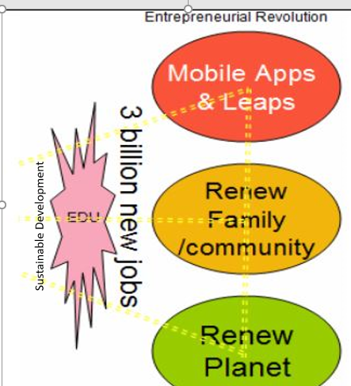
All over the world, Fintech (the application of tech to finance) has had dramatic exponential impacts, for better and worse
*Worse has been subprime virus that has trapped half a generation of youth mainly in West
*Good has been the liberation of small enterprises by financial technology – cases like Alibaba’s Alipay and BRAC’s bkas.comh are where we would recommend sustainable youth studying first
*Questionable is blockchain impact on currencies to date- while alumni of futurist Don Tapscott believe extraordinary solutions might one day emanate from blockchain, so far currencies like bitcoin have resulted in extreme gains and losses for a few in ways that are distracting given the urgency with which financing of sustainability goals needs to be mediated. Here is an extract from a talk of former wall street banker Mark Thornton June 2018 as a UN General Assembly summit convened around the stark challenge: 200 nations may have agreed the most urgent goals our species have ever encountered but as yet financial access for these goals stand is under 10% of what is needed for them to work
Our world’s financial system does not yet reflect our deepest and our highest values
If you imagine this circle here represents the world’s largest pool (308 trillion dollars worth) of liquid assets – bonds equities cash (deutsche bank estimate 2014). If we could sell 1% of these assets we could fund 154 united nations in year 1; in 5 years, a lot of headline solutions might be solved (or at least funded)
If you look at the domain of impact investing 100 mn $ that is the equivalent of the pen here; If you look at green bonds another 100 million dollars that’s this pen here. The solution to financing the sdgs is not going to come from creating more pens or bigger pens – if you quadruple the amount of impact investments you are still not going to fund 1 year of sdg replication
So we need to find a way to level the playing field of the 300 trillion dollars : let’s bends the market to what we most care about as human beings.
PovertyTech’s best news is that in May 2018 Alibaba’s Jack Ma formed his first partnership with part of BRAC so there is a chance that S Asia’s and China’s most relevant fintech wizards for small enterprises are coming together. Over two thirds of the world’s people live in the Eastern hemisphere so we recommend it is time that all hemispheres’ educators look at what livelihood solutions geared to sustainability goals The East is innovating. Be curious about which community solutions can networkers replicate at national borders and wherever communities are faced with severe sustainability challenges. Let’s map a tour of Jack Ma alumni and diary dates between now and Tokyo MAOlympics 2020
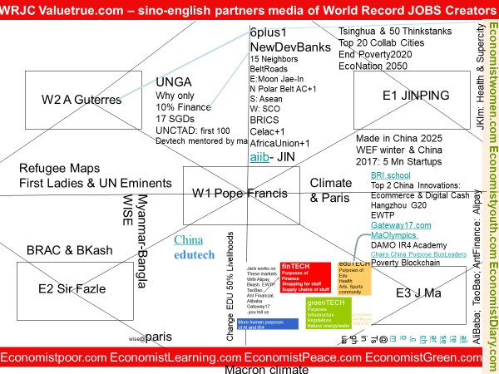
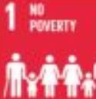  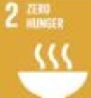  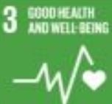  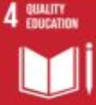  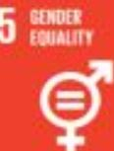  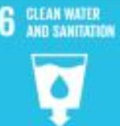  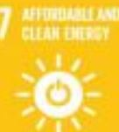  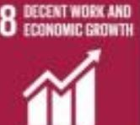  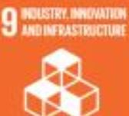  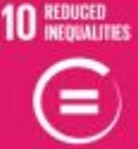  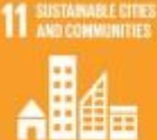  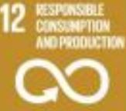  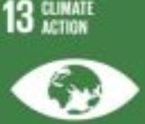  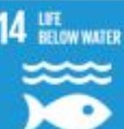  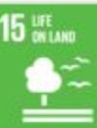  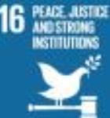  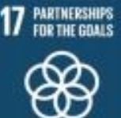 | What if optimistic future historians not Britannia nor Americana ruled the world.? As we humans mobilize race to be 1000 times more universally connected across communities- here are 2 most exciting episodes for choosing which future historians to value.: !972-1977 and NOW ! to 2025  NormanMacrae.net In 1972 the modern genre of future history was launched out of The Economist. It aimed to popularize the last chapter of Keynes General Theory of Employment, Interest and Money – what are the few systemic designs that rule the world because they exponentially lock places’ next generations into what their lives will be free and not free to do? 1972-1977 two segmented views:  The Economist Peacefully end centuries of colonization, carbonization, big get bigger. Value how knowhow networked humanity can be linkedin by Little Sister world of trust and love not Orwellian Big Brother world of fear and distrust Differentiate dismal zero-sum currencies like paper money and opium; from promising ones where the currency’s value exponentially appreciates locally sustainable human growth Map Coastal Belts and Overland Roads for a 21st century in which Asia Pacific of the epicentre of world trade led by China as we roll back colonisation’s lose-lose trading routes and walls between peoples Mainly American Futurists America’s 3rd century is placed to power the world’s futures-our science has just won the moon race, and we Americans deserve to be celebrated for making the world wars of the old world history We control the world’s media and the language scientific man thinks in and that business is done in. And we do so with a democracy that defines human ideals  NOW! Professor Mahbubani: well placed out of the 20th top port Singapore to compose a trilogy of books- Can Asians Think? Has the West l.ost It? Anyhow Aseans love intercultural diversity. Educated question: who’s futures are majority of world aged under 30 to organize work and happiness around?  - Economies whose size correlates approximately with population and win-win models of trade.  - 5% of world’s people always bigger economically, even than nations with 5 times more people  To pattern rules of worldwide trade out of Singapore, add hypothesis. There is much urgent work & learning to do: wherever the next child is born , she is to enjoy a fair chance of seeing sustainability blossom all around her family. Anywhere saying it can’t afford to employ all youth needs to change its political, media & economic models. eg Pope Francis EU Strasbourg  Q2 INFRASTRUCTURE WORLDS GREATEST NETWORK INNOVATION HOW 1975-2000 saw China’s Fifth of Humanity start inter-generational development. The Chinese Diaspora by connecting trade across 3 island superports Hong Kong, Singapore Taiwan and across to Korea’s Buzan became the 3rd wealthiest financial network. They brought new TECH & smart infrastructure knowhow: inward investments to mainland superports & fast trains connecting supercities across China  Back in 1975 there were no non-state companies. First, a wave of billionaire diaspora companies were asked to launch Chinese Capitalism. Second, mid 1980s future party leaders were sent to Tsinghua university and as graduate alumni were asked either to privatise state companies or map how different regions could become super jobs creators. Xi Jinping was one of the first Tsinghua alumni. His diaries in 1988 shos: he was regionally assigned to end poverty in a province adjacent to Shanghai. He became brilliant at asking 4 questions about village enterprises: how can we design franchise formats to maximise trade 1) in their own communitues; 2) with the nearest supercity in their region; 3) nationally 4) worldwide. All the while, how can we maximise win-win job creation across borders through trade wherever possible. Whilst never forgetting end poverty’s primary challenge, XI was later promoted to maximise Shanghai’s trading relationships with the world. And from 2012 how to rejuvenate the whole of China celebrating the half a billion under 30s as the greatest investment ever made  What changed China between 1975-2000 was both the most energetic celebration of corporations and the most sensibly designed map of Belt Superports connecting each other and inland cities by Railroads (and parallel pipes energy, water, cable). Only one continental mass had ever seen such an upgrade (USA half a century earlier). But this time civil engineering technologies were far more advanced; trains were a much more communal and greener transport than cars; digital superhighways could be built in parallel wherever straight line “ROADS” were invested in across the continent.. BRI.school
ER Mediating 3 Century Quarters (Q1=Q3) that will win or lose human sustainability
Urgent update 2018 : UN admits to having 17 sustainability goals but less than 10% financial access
The Entrepreneurial Revolution school of journalism started in The Economist at time of moon landing focused on optimism and valuing SME-centric markets. ER main hypotheses: by 2015 there would be 1000 times more communications TECH than 1946 mobilising every community worldwide; that the www would need to be designed as smartest learning media ever not advertising’s dumbest; that sustainable economics global2.0 would need to reverse the mercantile colonial age getting back to a time where all peoples – had equal opportunities to co-create; needed would be bottom-up financial, economic and microfranchise systems. Notable human celebrations :fintech digital banks for the poor, and girls valued as much as boys. Purposeful exponential auditing integrating small enterprises would be critical to valuing each market’s most sustainable purpose. More: Q2 overleaf | 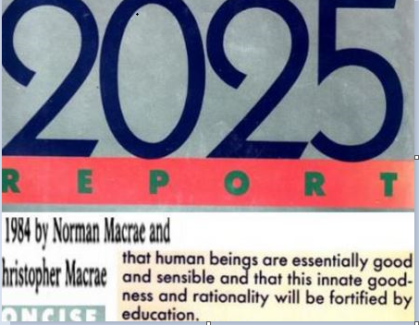

Foundations from Q1
Humanity’s global scorecard from 1950-1975 would suggest East and West hemispheres contributed uniquely to the human lot - for example America’s JFK waved optimism around the world with the moon race and America protected humanity from a 3rd and nuclear world war happening. Regarding sustainability the Eastern hemisphere invented superports, bullet trains, civil and electronic engineering with zero faults in many billion (thanks to western knowhow shared by eg Deming) The results were the Far East started to roll back the colonial win-lose model with a win-win model of world trade that Adam Smith would have been proud of . 400 years of mercantile colonization had all but wiped away human spirit and cultural memory Adam Smith’s hi-trust market hoped economists would make their Hippocratic Oath. So much value was created by the Oriental’s new model of world trade that by 1975 Japan and China’s diaspora had joined USA as the top 3 financial investment networks
What6 happened from 1976? ER win-win trading models continued to blossom in the East with a billion people in China rejoining world markets that they had withdrawn from in 1860 when Britain tried to turn opium into a currency. In contrast: western greedy tragedies -included Q3’s subprime and fake news crises in Q3; and throughout Q2 failure to resolve oil market crises with a transparent green energy race needed for 21st C youth to enjoy a peace dividend that the end-colonisation century had failed to deliver The good news for 2018 parents who truly want their children to be the sustainability generation is that girl-empowered fintech and edutech platforms now offer borderless and collaborative win-wins if all peoples can be cross-culturally humble enough to learn from each other.
Q3 2nd half : UN agrees 17 sdgs (see overleaf); China creates first tests of BRI.school
Consider China’s ER mediation of East-West dreams as we enter sustainability’s 7 make or break years: 2018-2025: Celebrate fintech debates emerging worldwide that are most interesting when mediated for poorest girls Attend to edutech debates of half of all youth everywhere will be unemployable unless … (see eg Jack Ma’s many offers to help youth)
Consider bri.school – why not: a quiz : where would your region vote for a new superport or superail to benefit all the neighbors it trades AND its own youth’s sustainability. NB 6 maps which Xi Jjinping is mediating (in true Adam Smith fashion – ie china’s self-interest (end poverty at west & south borders) win-win free trade with peace-seeking neighbors)
- Stans belt road connecting china landlocked central Eurasia, Gulf, Suez, Med
- Railroad across Eurasia connecting China, Europe and everywhere on the old world’s main continent in between
- The Korean peace roads and Olympics Unites all youth’s joy of futures
- With the arctic circle, the polar belt road which asks interalia can Russia becoming as positive a northern landmass as Canada also save the world’s climate
- Asean belt road celebrating cultural interaction with all the gusto that Singapore has hubbed through Asean
- Girls belt road – can bkash and Alipay models viralise across s asia given that china and Bangladesh are the 2 nations that most value girls hold up half the sky & SME value china are integral to mapping all 17 sustainability goals connectivity with ending the economic and social disparity between the sexes normalized by industrial and colonial ages, but which have no place in 21sT C post-colonial world and jobs-rich mobile innovation era of IR4

